•

New York city review for XYZ

Company.

•

Optimum location for new

Restaurant business

•

Business Problem :

-

Choice of first neighborhood to

start restaurant business.

-

Easy to replicate.

-

Low competition

-

High demand

-

Choice of Menu

•

Success Criteria :

-

Best neighborhood which meets

above criteria.

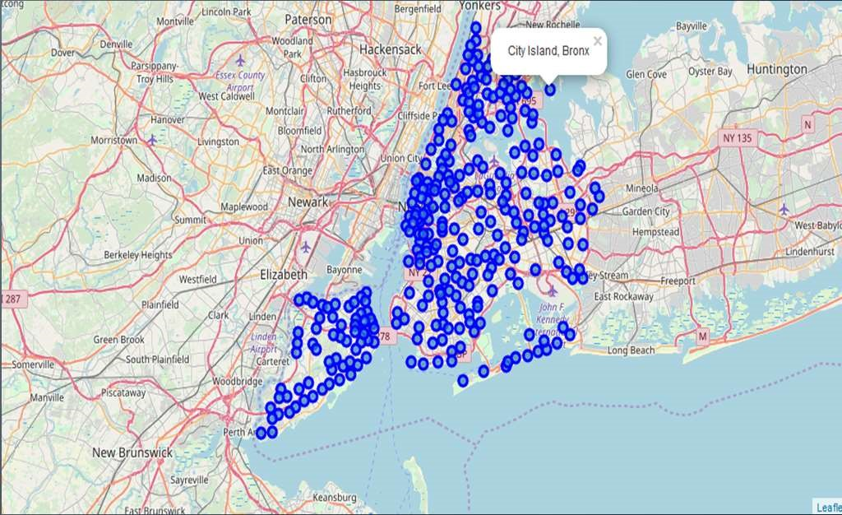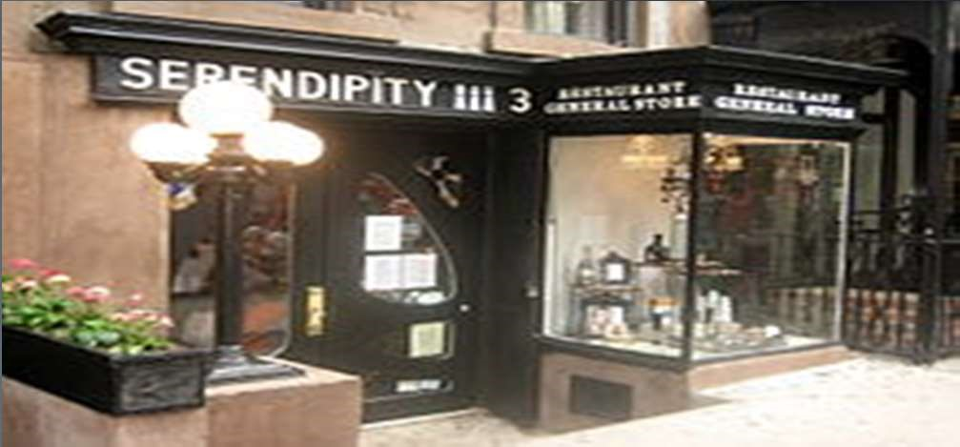

USA

•

Most populous city in the United States

•

It is diverse and is the financial capital of

•

Provides lot of business opportunities

•

Business friendly environment

•

Attracted many different players into the

•

Global hub of business and commerce.

•

The city is a major centre for banking and

finance, retailing, world trade,

transportation, tourism, real estate, new

media, traditional media, advertising,

legal services, accountancy, insurance,

theatre, fashion, and the arts in the

United States.

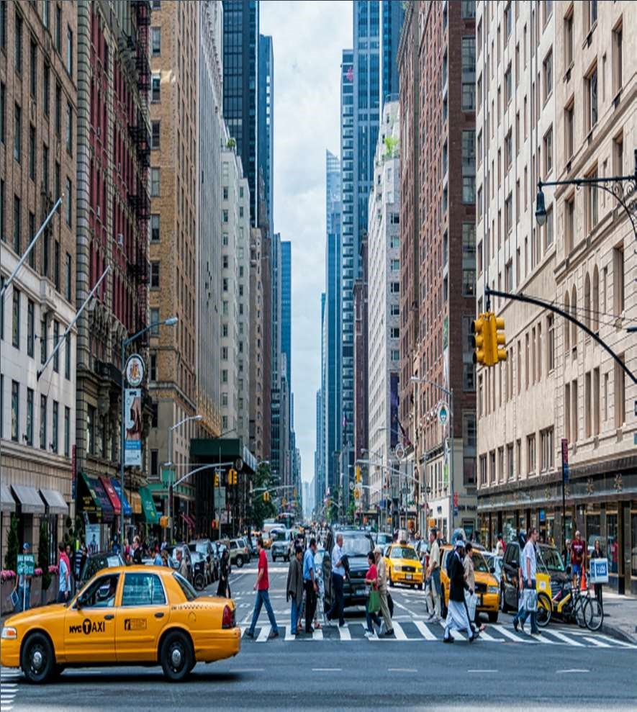

* It is multicultural

market

* Market is highly competitive
* Highly developed city so cost of doing business is also one of the highest
* New business venture or expansion needs to be analysed carefully
* One should strategically targeting the market inorder to – -This will help in reduction of risk.

-The Return on Investment will be reasonable.

The City of New York is famous for its excellent cuisine. It's food culture includes an array of international cuisines influenced by the city's immigrant history.

* Central and Eastern European immigrants, especially Jewish immigrants - bagels, cheesecake, hot dogs, knishes, and delicatessens
* Italian immigrants - New York-style pizza and Italian cuisine
* Jewish immigrants and Irish immigrants - pastrami and corned beef
* Chinese and other Asian restaurants, sandwich joints, trattorias, diners, and coffeehouses are ubiquitous throughout the city
* Mobile food vendors - Some 4,000 licensed by the city
* Middle Eastern foods such as falafel and kebabs examples of modern New York street food
* Famous for fine dining Michelin starred restaurants. The city is home to "nearly one thousand of the finest and most diverse haute cuisine restaurants in the world", according to Michelin.
* So it is evident that to survive in such competitive market it is very important to strategically plan.

* New York Population
* New York City Demographics
* Are there any Farmers Markets, Wholesale markets etc nearby so that the ingredients can be purchased fresh to maintain quality and cost?
* Are there any venues like Gyms, Entertainmnet zones, Parks etc nearby where floating population is high etc
* Who are the competitors in that location?
* Cuisine served / Menu of the competitors
* Segmentation of the Borough
* Untapped markets
* Saturated markets etc The list can go on...

* Data 1 : Neighborhood has a total of 5 boroughs and 306 neighborhoods. In order to segment the neighborhoods and explore them, we will essentially need a dataset that contains the 5 boroughs and the neighborhoods that exist in each borough as well as the latitude and longitude coordinates of each neighborhood.
* This dataset exists for free on the web. Link to the dataset is : https://geo.nyu.edu/catalog/nyu_2451_34572

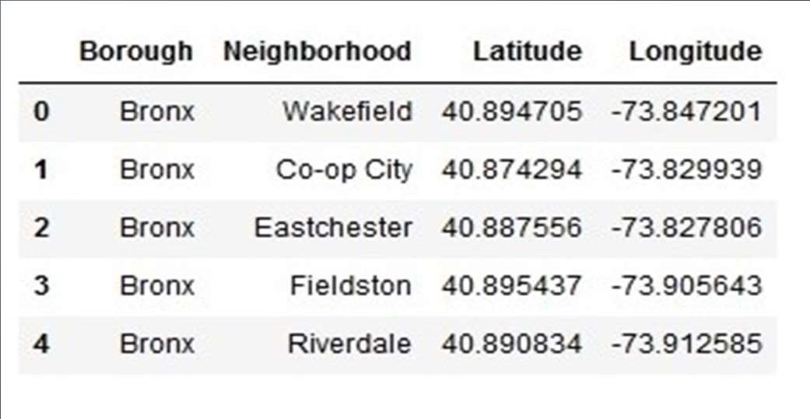

* Data 2 : Farmers Markets data -
* https://data.cityofnewyork.us/dataset/DOHMH-Farmers-Markets-andFood-Boxes/8vwk-6iz2
* A farmers' market is often defined as a public site used by two or more local or regional producers for the direct sale of farm products to consumers. In addition to fresh fruits and vegetables, markets may sell dairy products, fish, meat, baked goods, and other minimally processed foods.

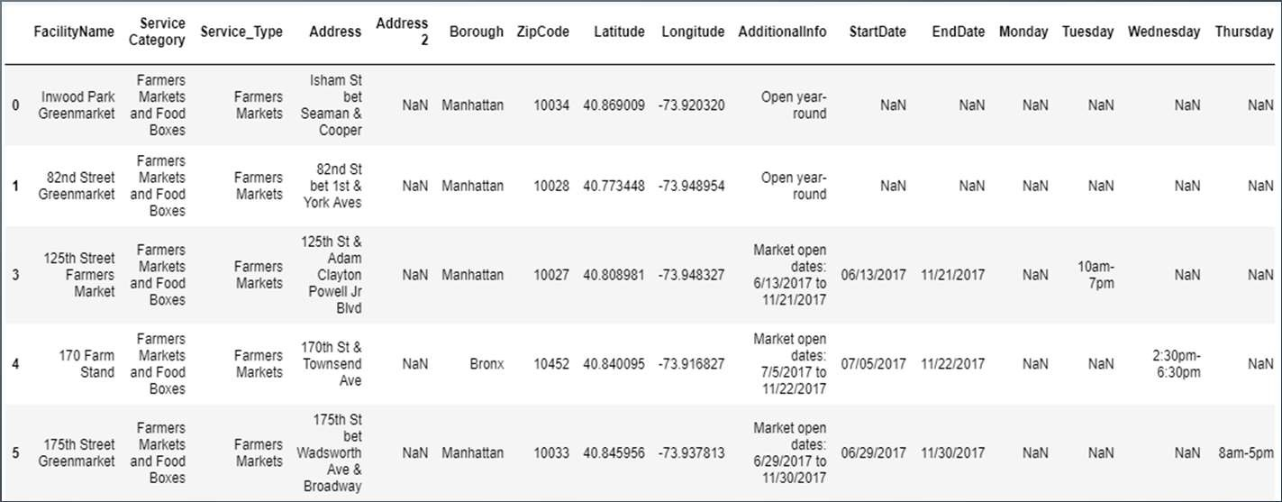

Data 3 : Data from Wikipedia pages as given below :

* New York Population
* New York City Demographics • Cuisine of New York city https://en.wikipedia.org/wiki/New_York_City https://en.wikipedia.org/wiki/Economy_of_New_York_City https://en.wikipedia.org/wiki/Portal:New_York_City https://en.wikipedia.org/wiki/Cuisine_of_New_York_City

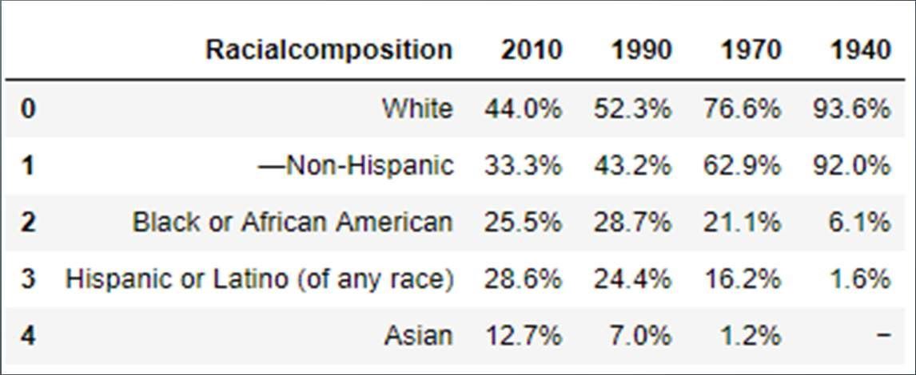

* Data from foursquare.com

Newyork city geographical coordinates data will be utilized as input for the Foursquare API, that will be leveraged to provision venues information for each neighborhood.We will use the Foursquare API to explore neighborhoods in New York City. The below is image of the Foursquare API data.

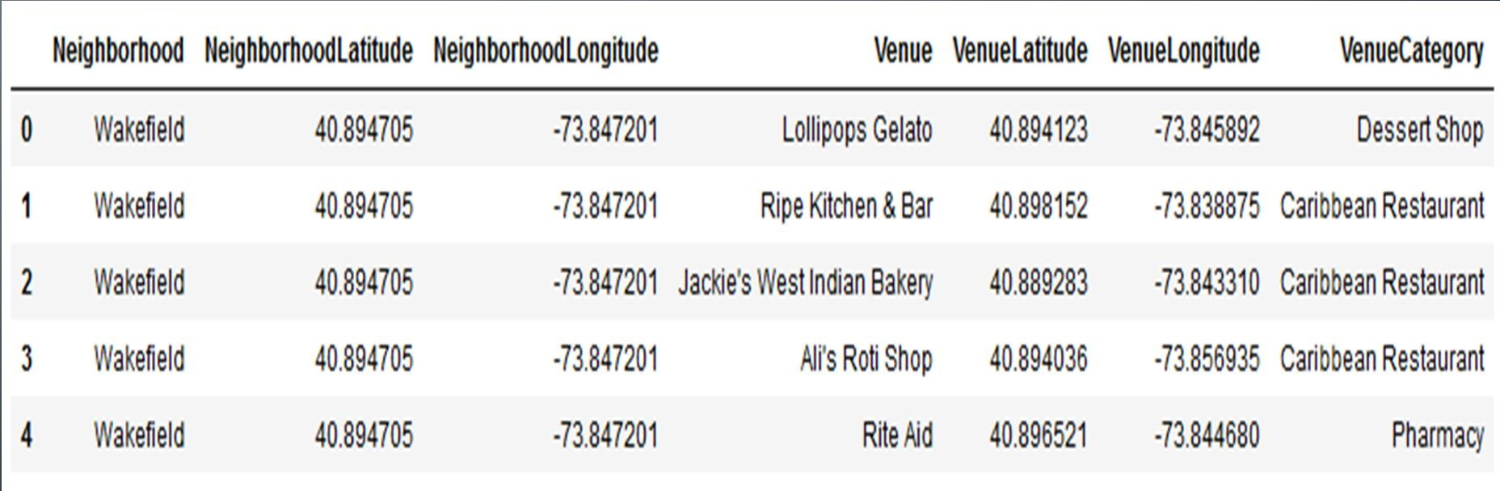

* New York city neighbourhood has a total of 5 boroughs and

306 neighborhoods

* PART 1 - Clustering of Manhattan and Brooklyn
* PART 2 - Clustering of Bronx, Queens and Staten Island.
* Only restaurant data is filtered from foursquare.com venues data and utilized for this project.

* This is done because of the following Exploratory data analysis.

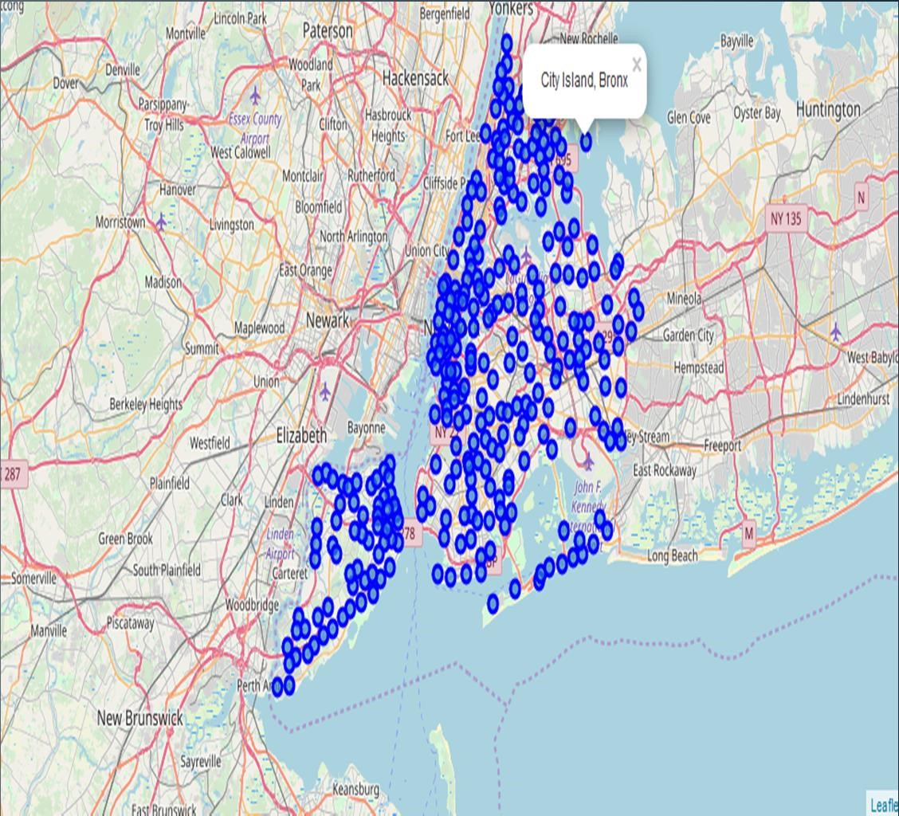Data 1- New york city Geographical Coordinates Data.

* Load the data and explore data - newyork_data.json
* Transform the data of nested python dictionaries into a pandas dataframe.
* Dataframe contains the geographical coordinates of New York city neighborhoods.
* Data will used to get Venues data from Foursquare.
* Geopy and folium libraries used to create a map of New York city with neighborhoods superimposed on top.

* 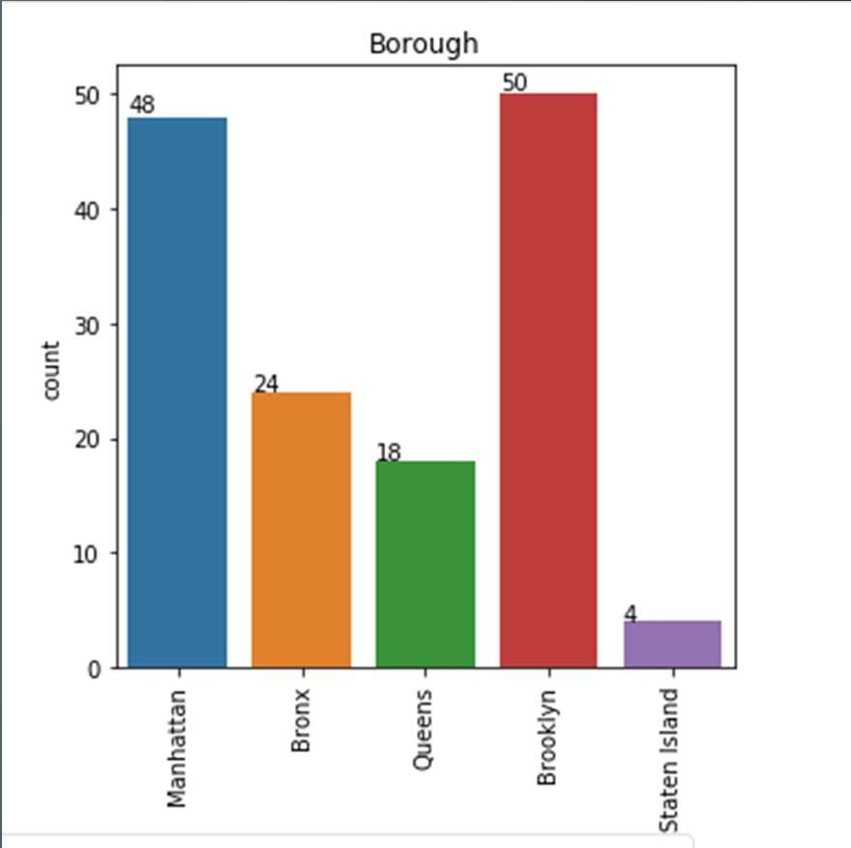Data 2- DOHMH Farmers Markets and Food Boxes dataset.
* In this we will be using the data of Farmers Markets
* There are totally 144 Farmers Markets in New York city.
* Highest number are in Manhattan and Brooklyn.And lowest in Queens, Bronx and Staten Island.
* Farmers Market visualisation-New York City

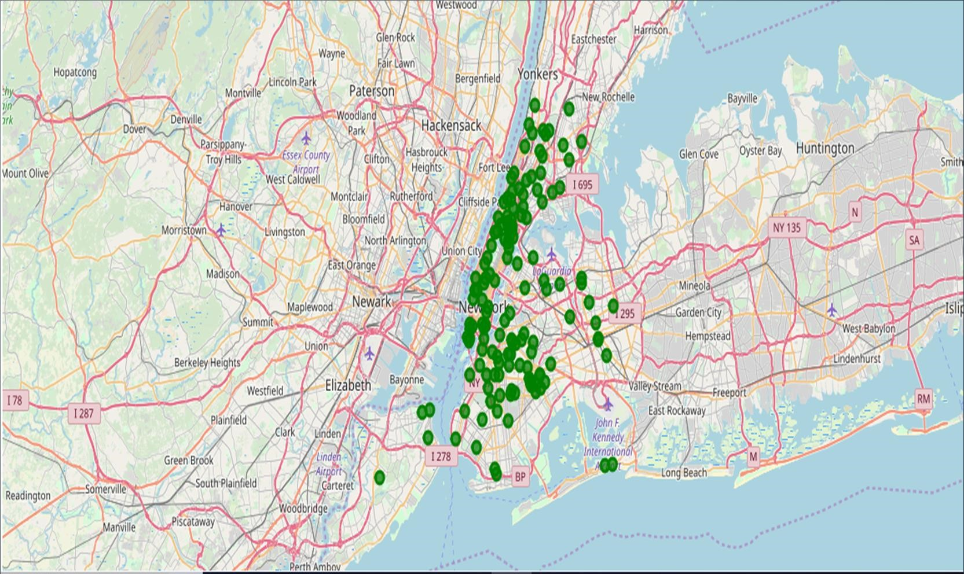

* Data 3 : To analyize New York city Population, Demographics and Cuisine , scrapped the data from Wikipedia pages given above in the data section.
* We used BeautifulSoup python library.
* Beautiful Soup is a Python package for parsing HTML and XML documents (including having malformed markup, i.e. non-closed tags, so named after tag soup).
* It creates a parse tree for parsed pages that can be used to extract data from HTML, which is useful for web scraping

* Manhattan (New York County) is the geographically smallest and most densely populated borough.
* Manhattan's (New York County's) population density of 72,033 people per square mile (27,812/km²) in 2015 makes it the highest of any county in the United States and higher than the density of any individual American city.
* Brooklyn (Kings County), on the western tip of Long Island, is the city's most populous borough.
* Queens (Queens County), on Long Island north and east of Brooklyn, is geographically the largest borough.

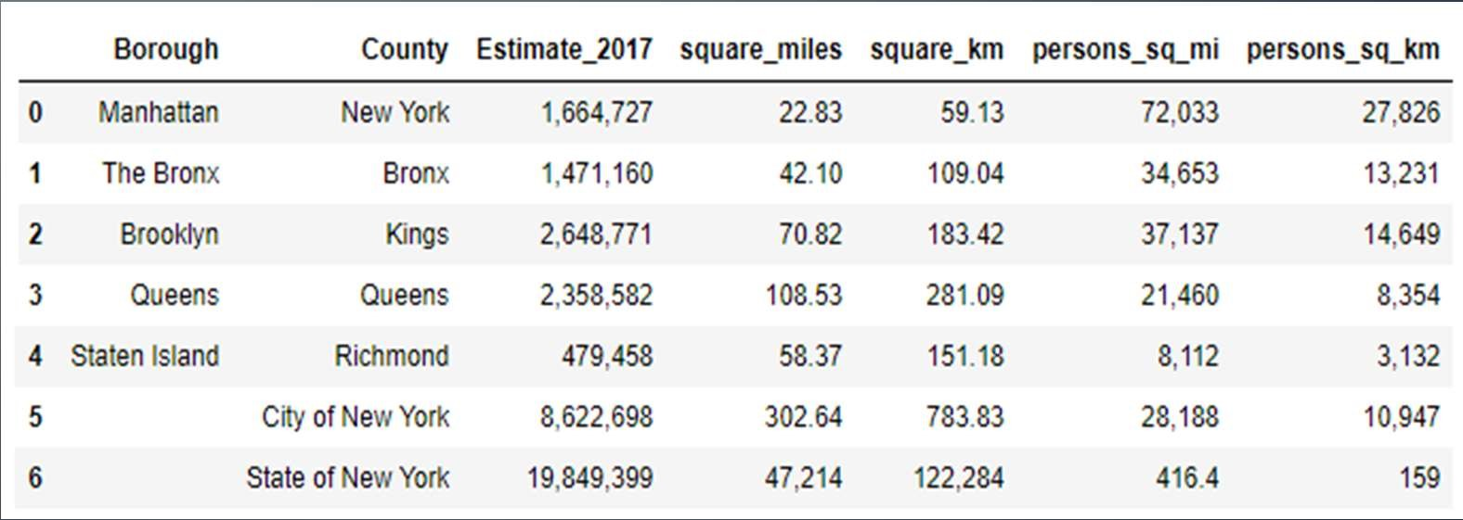

* New York City is the most populous city in the United States , with an estimated record high of 8,622,698 residents as of 2017,incorporating more immigration into the city than outmigration since the 2010 United States Census.
* The racial composition is as given below. This is the reason New York city has restaurants serving cuisine from many countries such as India, Africa, Japan etc. This also increases the scope for restaurants business in New York City.

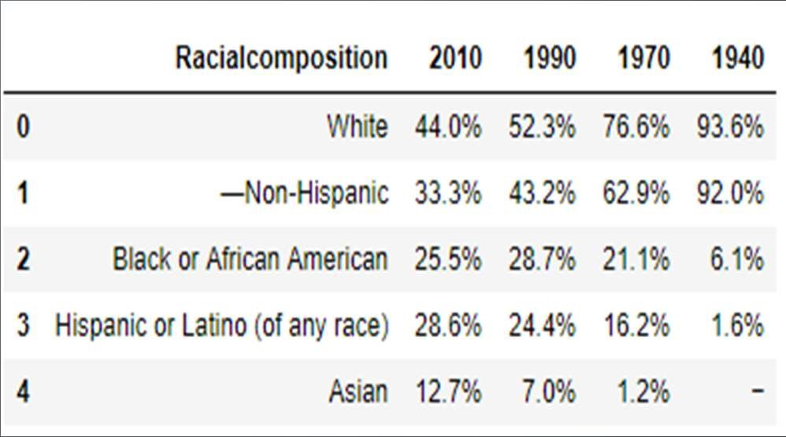

* This data has been manually prepared. Data is taken from Wikipedia page

- https://en.wikipedia.org/wiki/Cuisine_of_New_York_City

* Data used to create word cloud.

NEW YORK CITY CUISINE : Most Preferred Food in New York City –Italian,

Purto Rican, Mexican, Jewish, Indian, Pakistani & Dominican

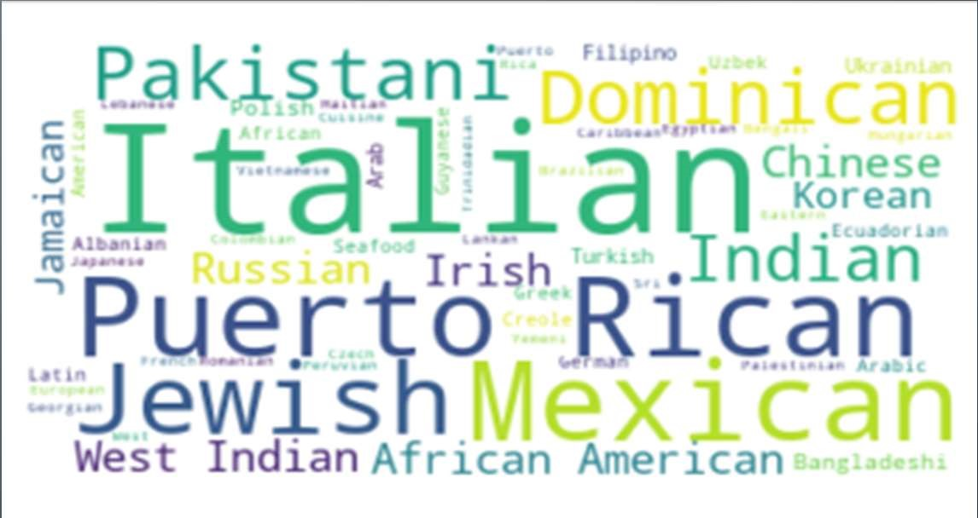

•

BROOKLYN CUISINE

-Most

Preferred Food in Brooklyn is –

Italian, Purto Rican & Mexican

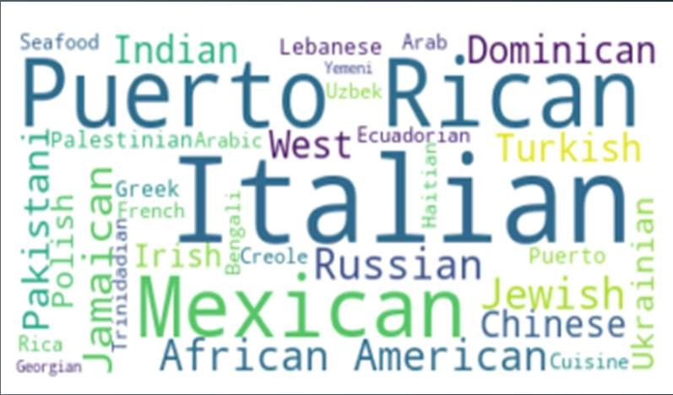

* 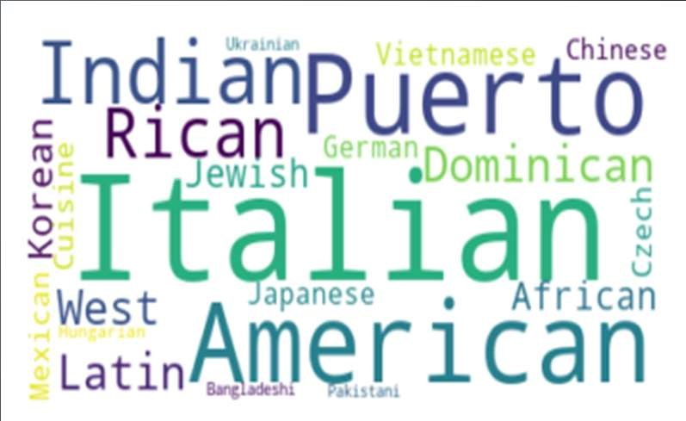MANHATTAN CUISINE - Most

Preferred Food in Manhattan is – Italian, American, Puerto Rican and Indian.

•

QUEENS CUISINE -

Most

Preferred Food in Queens is

– Indian, Irish, Pakistani and

Mexican.

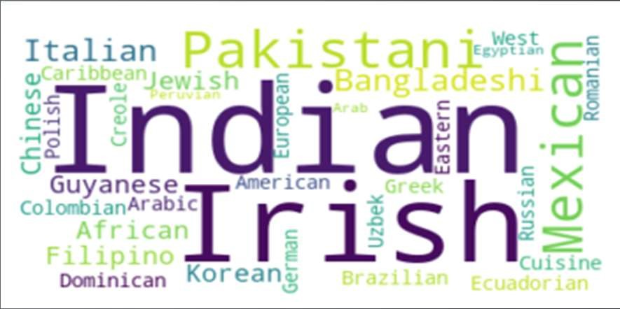

* 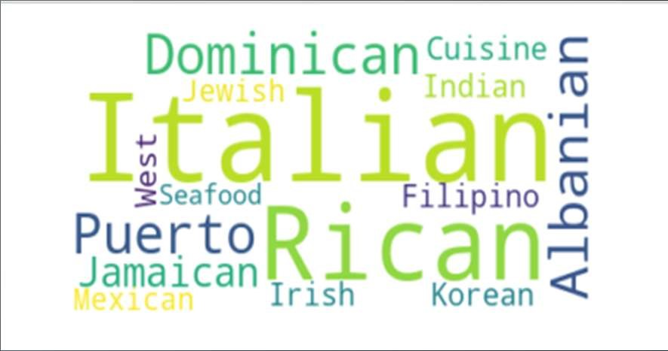THE BRONX CUISINE - Most Preferred Food in The Bronx is – Italian, Puerto Rican,

Albanian and Dominican.

* NewYork city geographical coordinates data has be utilized as input for the Foursquare API, that has been leveraged to provision venues information for each neighborhood.
* We used the Foursquare API data to explore neighborhoods in New York City.
* Using the geographical coordinates of each neighbourhood foursquare API calls are made to get top 200 venues in a radius of 1000 meters

PART – 1 Brooklyn and Manhattan

PART – 2 Bronx, Queens and Staten Island

Brooklyn and Manhattan Venues data

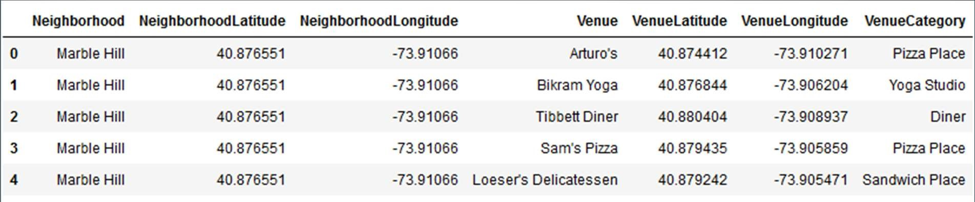

Brooklyn and Manhattan Visualization

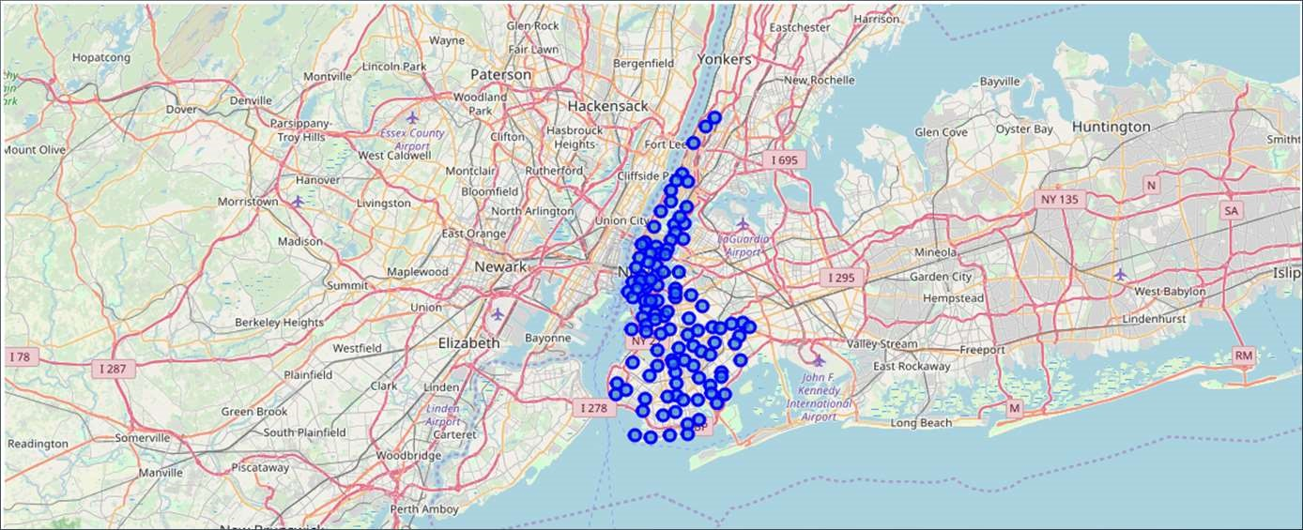

Brooklyn and Manhattan Venues Visualization : Generated the below Brooklyn and Manhattan Venues Visualization. The "BM_venues" dataframe has 9708 venues and 397 unique venue types.

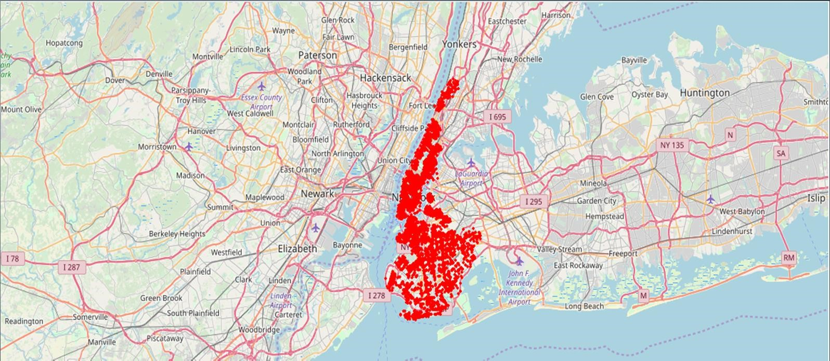

Bronx, Queens and Staten Island Venues data



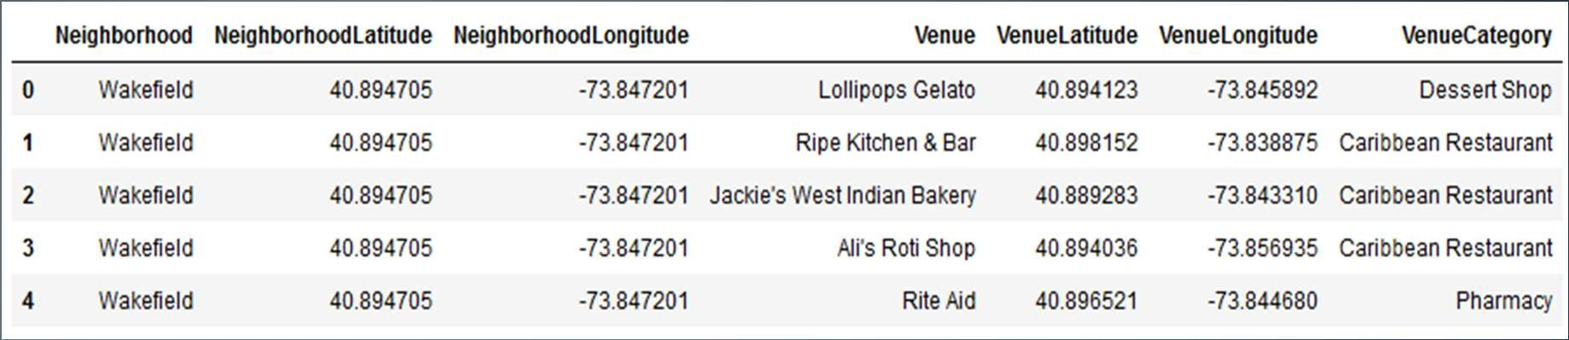

Bronx, Queens and Staten Island Visualization

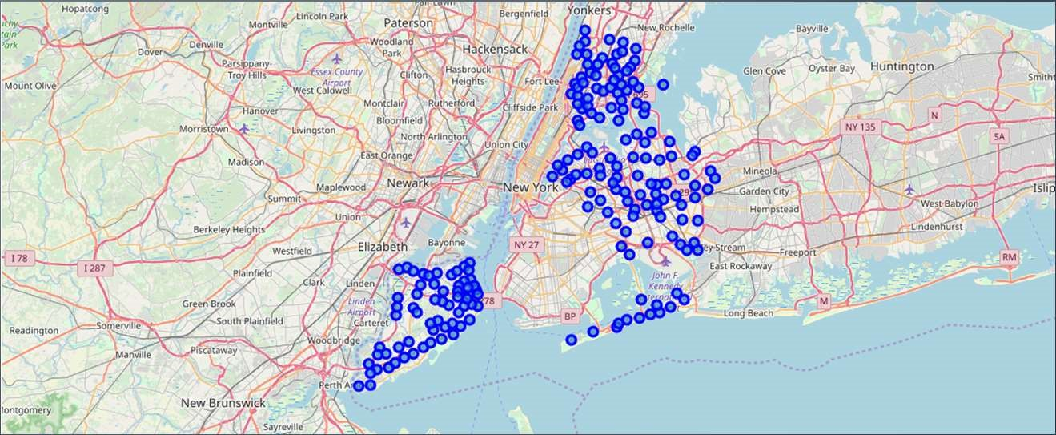

Bronx, Queens and Staten Island Venues Visualization : The "BQS_venues" dataframe has 10805 venues and 387 unique venue types.

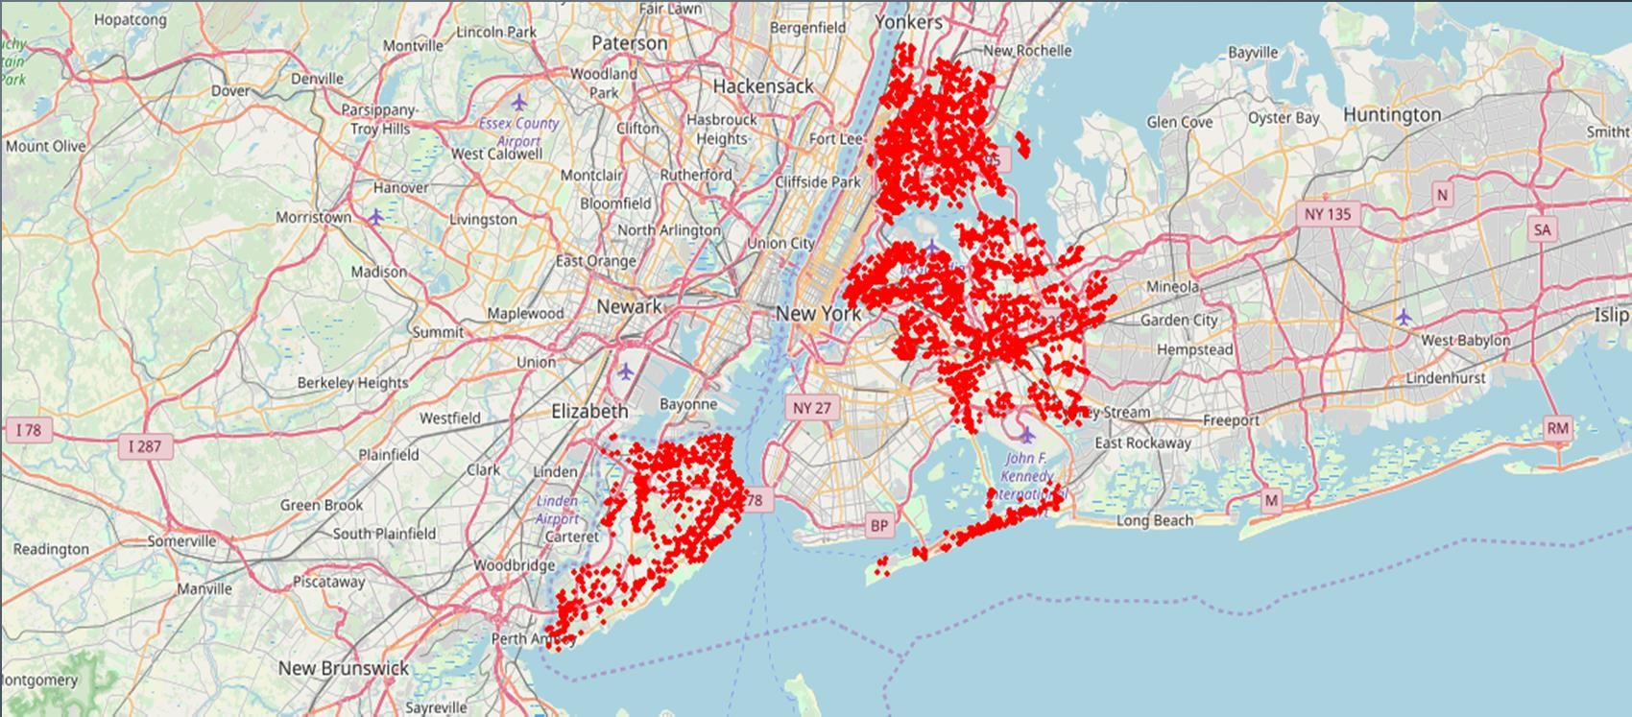

• Segmenting and Clustering Neighborhoods

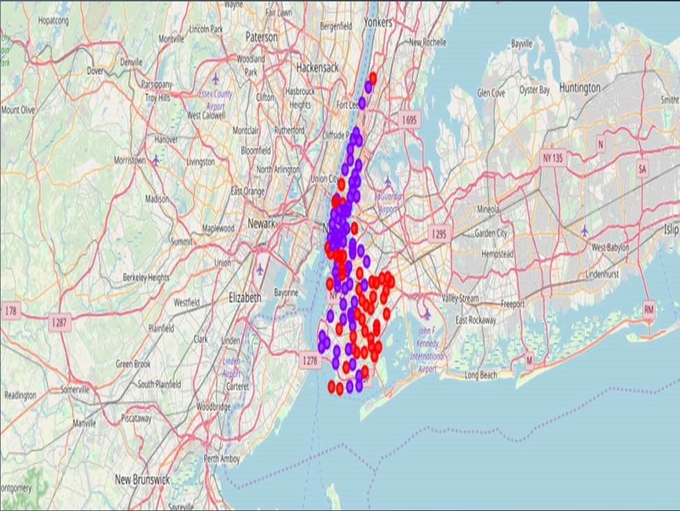

* Cluster0 : The Total and Total Sum of cluster0 has smallest value. It shows that the market is not saturated.

* Cluster1 : The Total and Total Sum is very high. Lot of competition. Saturated neighborhoods.

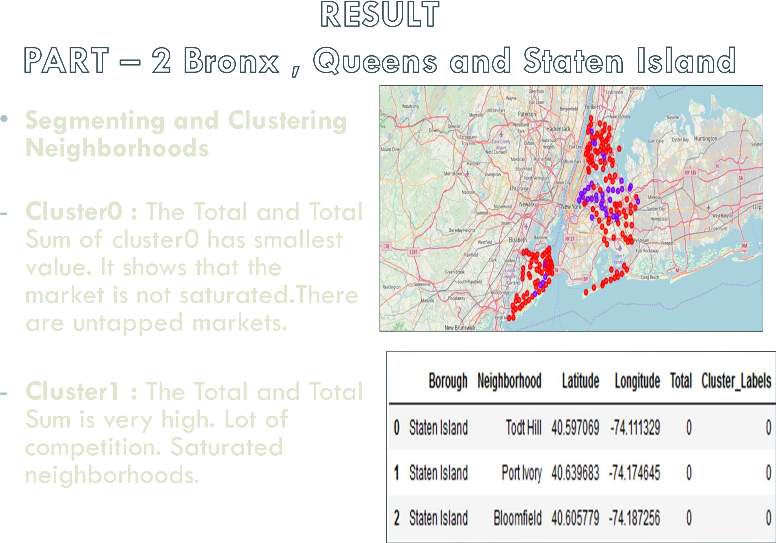

* Scope to explore cuisines of various countries in Bronx, Queens and Staten Island

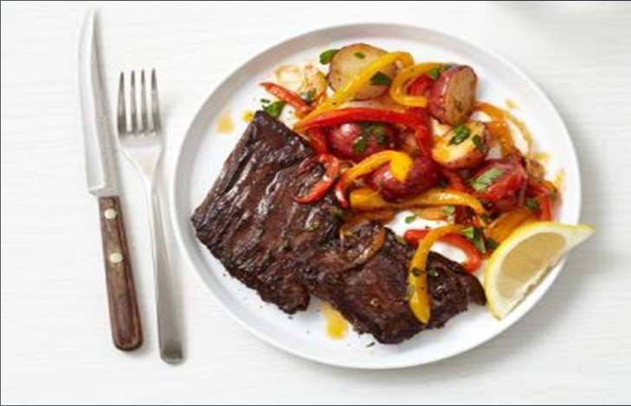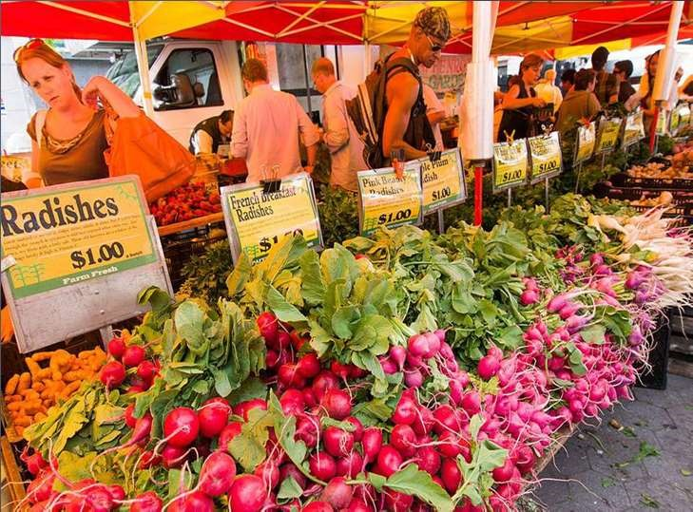

* In Manhattan and Brooklyn restaurants , cuisines of many countries are part of their Menu. Risk can be taken with great menu on board. It also shows people love and explore cuisines of various countries.
* Scope to increase Farmers markets in Bronx, Queens and Staten Island.
* Region - Cluster0
* Neighborhood – Staten Island – Tod Hill, Port Ivory, Bloomfield

•

Analysis performed on limited data

•

Re-run program with updated information

•

Brooklyn and Manhattan

has high

concentration of restaurant business. Very

competitive market.

•

Bronx, Queens and Staten Island

also

has good number of restaurants but not

as many as required. So this can be

explored.

•

As per the neighbourhood or restaurant

type mentioned like Indian Restaurant,

analysis can be checked. A venue with

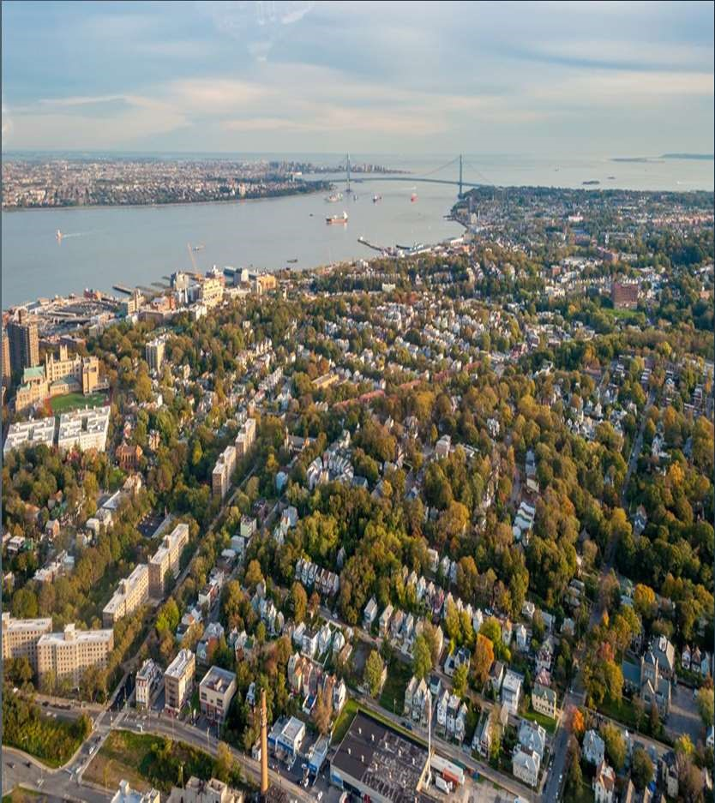

lowest risk and competition can be identified